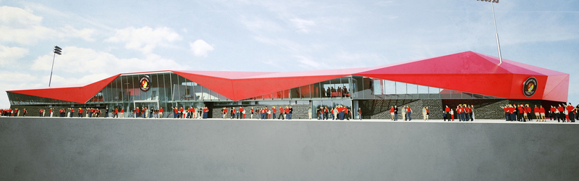
E X E C U T I V E B O A R D R O O M P A C K A G E
S E A S O N 2 0 1 7 / 1 8

Secure An Exclusive Space In The Club Boardroom At
Stonebridge Road By Purchasing The Executive Boardroom Package

Executive Boardroom Package - £700 +vat
Access To The Club’s Boardroom For Every Home League Game
Refreshments Available Pre-Match, At Half Time And Post-Match
Reserved Directors’ Box Seating
Complimentary Car Parking Pass

DETAILS:

Name: __________________________

Email: ___________________________________ Tel: ___________________________

Address (For Invoicing): Address (For Boardroom Pass):

_____________________________ _____________________________

_____________________________ _____________________________

Postcode: _____________________ Postcode: _____________________

BOARDROOM PASS SELECTION:

Single Pass Purchase: ________________

Multiple Pass Purchase: ______________ Number Of Passes Required: ______________

To Confirm Your Executive Boardroom Package Please Complete This Form
And Return To The Club Office Or By Email To matthew.faithorn@eufc.co.uk

